Summer temperature during the past two millennia derived from an ultrahigh resolution total air content record of the Tibetan Chongce ice core

Jing Song1, Xavier Faïn2, Wangbin Zhang1, Jérôme Chappellaz2, Ke Liu1, Jochen Schmitt3,4, Loïc Schmidely3,4, Babara Seth3,4, Hubertus Fischer3,4, Thomas Stocker3,4, Shuang-Ye Wu5, Hongxi Pang1, Renhui Huang1, Theo M. Jenk4,6, Margit Schwikowski4,6, Shugui Hou1,7*

1School of Geography and Ocean Science, Nanjing University, Nanjing, 210023, China.

2Université Grenoble Alpes, CNRS, IRD, Grenoble INP, IGE, 38000 Grenoble, France

3Climate and Environmental Physics, Physics Institute, University of Bern, Sidlerstrasse 5, 3012 Bern, Switzerland

4Oeschger Centre for Climate Change Research, University of Bern, 3012 Bern, Switzerland

5Department of Geology, University of Dayton, Dayton, OH 45469, USA

6Laboratory of Environmental Chemistry, Paul Scherrer Institute, 5232 Villigen PSI, Switzerland

7School of Oceanography, Shanghai Jiao Tong University, Shanghai, 200240, China

*Corresponding author.

E-mail address: shugui@nju.edu.cn (S. Hou)

**Abstract:**

Ice core with summer melt has unique physical properties that the Total Air Content (TAC) can be used to trace past melt and summer temperature. Due to measurement constraints, two available TAC sequences from Tibetan Plateau (TP) ice cores was poorly resolved, thus not allowed for detailed observation of specific summer melt features. Here we report a highly resolved TAC sequence from an ice core drilled at the Chongce ice cap, Northwestern TP. The measurement was based on a method of Continuous Flow Analysis (CFA), which was further calibrated against the discrete TAC records that measured by conventional method. By further analyzing the influence of summer-melt on ice core physical properties, we proved that TAC variation was in depending on glacier melt at summertime. From the continuous TAC series, seasonal variation of TAC was observed, and several melting events also identified at the top layers of ice core. Smoothing to the continuous TAC sequence allowed for further analyzing relative summer warming during the past 2000 years. As a result, decades of significant summer warmth and coolness were identified. Five periods of summer temperature change were also recognized according to centennial variation of TAC records. Similar to what observed in previous TAC record, relative summer warmth derived in our record was inconsistent to most temperature records across the Northern Hemisphere. Specifically, there was an apparent cool summer condition during the Medieval Warm Period (MWP), and a less significant summer coolness during the Little Ice Age (LIA). Seasonal bias of ice core TAC to other paleoclimate proxies may contribute to the climatic divergence. Elevation amplified warming may also explain the warming LIA in the Chongce ice core TAC. Our research also highlights the needs for more long-term TAC records with high temporal resolution, which can be used to further constrain the seasonal bias that described in the Holocene temperature conundrum.

**Key words:** Total Air Content; ice core; summer temperature; Tibetan Plateau

## 1. Introduction

Numerous temperature reconstructions from regional to global scale show pronounced cooling in the transition from the middle to Late Holocene, while the model inferred global annual temperature exhibit oppositely warming that in response to the global warming forcing of ice sheets retreat and atmospheric greenhouse gases rises (*Liu et al.*, 2014). The conflict between proxy-based and model-based paleoclimate in the Holocene led to the so-called ‘Holocene temperature conundrum’, which may indicate uncertainties in the proxy-based temperature reconstructions (*Liu et al.*, 2014; *Wu et al.*, 2018). Over the past decades, significant progress has been made towards proxy-based temperature reconstructions in Tibetan Plateau (TP). These proxies include annual tree ring (*Wang et al.*, 2015; *Xu et al.*, 2019), ice core δ18O (*Hou et al.*, 2019), stalagmite (*Liu et al.*, 2015), and lacustrine deposit (*Aichner et al.*, 2015). Ice core δ18O, for example, has extended our understanding of paleoclimate in TP to millennial scale, while large uncertainties still exist in the interpretation when δ18O was applied as a proxy to past temperature in TP, especially the Eastern TP that influenced by Indian monsoon (*Hoffmann & Heimann*, 1997; *Zhang et al.*, 2005). In order to avoid uncertainties in the interpretation of proxy data, natural archives with solely summer temperature significance are still needed, which is therefore paramount in exploring seasonal contribution to the ‘Holocene temperature conundrum’.

As an important physical index of ice core, Total Air Content (or ice core porosity) can be used to trace past summer melt (*Bendel et al.*, 2013; *Paterson*, 1994). For ice cores developed where surface melting occurs, the summer melting can be recorded by ice core TAC that the penetration of melt water would block the pores and cause the TAC of the summer layers to decrease (*Bendel et al.*, 2013; *Paterson*, 1994). This is a preferred method for relative summer warmth reconstruction, because the relative summer warmth reflected by ice core TAC should not affected by other climatic factors, such as winter temperature or summer precipitation. In the previous research of Holocene summer temperature variation, TAC data in ice cores from polar sites has been used as a proxy of past summer melting (*Das & Alley*, 2008; *Paterson*, 1994). In the research of summer climate change in TP, discrete TAC sequences along the ice cores has been reconstructed, while the temporal resolutions were insufficient to analyse the timing and relative amplitude of summer temperature changes at decadal over the past two millennia (*Hou et al.*, 2007; *Li et al.*, 2011).

In this study, the Continuous Flow Analysis (CFA) was used to track TAC in ice core drilled from Chongce ice cap, Northwestern TP. The measurement allowed for acquisition of ultrahigh resolution of ice core TAC. To ensure the data accuracy and consistency relative to previous TAC researches, conventional approach of discrete analysis was also applied. Here the continuous TAC sequence would allow to meaningfully interpret the TAC signal and to capture new features of summer temperature changes over the past 2000 years.

## 2. Material and Methods

### 2.1 The Chongce ice core

In 2013, we recovered a 216.6 m surface-to-bedrock ice core from Chongce ice cap at an elevation of 6100 m a.s.l. on the West Kunlun Mountains, Northwestern TP (35°14′57′′ N, 81°5′28′′ E; Figure 1a). The study of the glacial evolution of the West Kunlun Mountains shows that the natural environmental conditions of the Chongce ice cap were relatively stable throughout the Holocene (*Jiao et al.*, 2000). The average snow accumulation rate at this site from 1963 to 2013 was 297 mm w.e. year-1, and the borehole temperature at 10 m depth of this ice core was -12.6 °C (*Hou et al.*, 2019; *Hou et al.*, 2018). HAR data with a resolution of 10 kilometers shows that the average annual temperature of the ice core drilling site from 2004 to 2013 was -12.8 °C, and the highest daily temperature in these years reached 5.4 °C (*Maussion et al.*, 2014).

According to the firn densification curve (Figure 2a), transition depth from firn to ice was estimated to be 29.79 m, where the ice density reaches 830 kg m-3. Because firn layer has a relative low density that fragile to cut or shipment, the top 29.79 m was not performed on measurements. The deepest 51 cm of the ice core was also not used for the measurement because it contains a large amount of dirty layer, which would not applicable to CFA.

In the study, ice core segments with a depth ranging from 29.76 m to 216.10 m were collected and further used for gas analysis. Further analysis of summer temperature variation (see 3.5) was mainly focused on the depth range of 29.76 m to 195.63 m, which corresponding to the ages ranging from 200 AD to 1917 AD. The age scale was based on a two parameter (2p) ice flow model. Absolute dating of 14C, 210Pb, tritium, and β activity were also derived. The age at the ice-bedrock interface was estimated of $8.3±_{3.6}^{6.2}$ ka BP, which agrees well with the age scale of most TP ice cores (*Hou et al.*, 2018). Since TAC is related to the ice ages, here we adopted the ice chronology from 2p model (*Hou et al.*, 2007; *Li et al.*, 2011).

### 2.2 Continuous Flow Analysis (CFA)

Continuous TAC data were extracted from the Chongce ice core using the CFA setup available at the Institut des Geosciences de l’Environnement (IGE, Grenoble, France; formerly LGGE). General description of this method is provided by (*Stowasser*, 2013), and a specific description of the IGE CFA setup, specifically designed for continuous gas measurements, is reported by (*Fourteau et al.*, 2017). In this study, we analyzed 186 sticks of ~1 m long ice core for depth ranging 29.76 m to 216.10 m of the Chongce ice core. Ice sticks were cut in the cool room of Nanjing University (about -15 °C, similar to temperature observed at the drilling site), and melted at IGE during a 13 days analytical campaign in February 2018. The Chongce ice sticks were measured sequentially from 178.0 m to 29.76 m depth for 9 days, and finished the campaign by melting from 216.10 m to 178.0 m depth, with an average melting rate of 5.4 cm min-1. The first melted Ambient air infiltration can potentially contaminate the gaseous sample flow when ice sections with cracks or ice stick ends reach the melter. To limit such contamination, both top and bottom ends of each ice stick were flattened so as to create a flat surfaces to fit the two consecutive core sticks on the melter as closely as possible.

Briefly, ice core sticks were cut at a 34 mm × 34 mm cross section and processed on a melt head located in a cool room. The melt head is composed of inner and outer collection areas. Inner area is dedicated to collect sample, while the outer area allows to exclude the surface of the ice stick which can be potentially contaminated. The water and gas bubble mixture is continuously pumped via a debubbler into a temperature-controlled gas extraction unit maintained at 30°C. The gas is extracted by applying a pressure gradient across a Transfer-Line (Idex degasser) gas-permeable membrane. Then, the gas is dried by a Nafion (Perma Pure) dryer before being transferred to a laser spectrometer (SARA analyzer, based on optical feedback cavity enhanced absorption spectrometry). The system operation was kept unchanged during the entire analytical campaign, with pump tubing replaced every 3 days. The laser spectrometer allows for continuous detection of methane and carbon monoxide mixing ratios, but it also records continuously the sample gas flow (STP) through its optical cavity. The pressure of the optical cavity is maintained at 20 mbar by using a Photoionization Detection (PID) regulated by electro-valve (from Bronkhorst, Montigny les Cormeilles, France) located at its outlet. A needle valve that is located at the inlet of the spectrometer allows to set up the pressure at the outlet of the degasser. While this extraction pressure was usually maintained at 400 mbar, it regularly falls to lower value when a bubble-free ice layer was measured, i.e., when no gas was available for extraction. In these specific situations, we observed a decrease in pressure in the optical cavity of the spectrometer. We interpret such decreases to the fact that the electro-valve does not fully close (with a leak rate of about 0.3 ml min-1), and thus the external pump keeps vacuuming the optical cavity when no more gas is available at the inlet. Such effect resulted in a non-zero flow observed when bubble-free ice was measured. In this study, the pressure of the optical cavity has been used to set criteria to identify period where no gas was available (Figure S1).

In order to calculate the continuous TAC from the gas flow rate, we introduce a scaling factor between gas flow rate and TAC. According to the ratios between discrete TAC and overlapped mean values of continuous gas flow rate, the factor was determined to be 42.68 ± 8.62 (Figure S2). According to equation S (1) that described the intrinsically physical relationship between the gas flow rate and TAC, a scaling factor of 42.89 was also derived, with uncertainty intervals estimated to be 35.45 and 53.40. The similarity of the two independent results suggests that both estimation about the scaling factors were reasonable (Figure S3). Here the value of 42.68 ± 8.62 derived from the first calculation was then used for continuous TAC calculation, because a fraction of gas dissolves in the liquid sample stream was not extracted by the In Line Idex degasser of CFA system (*Fourteau et al.*, 2017). In this work, a total number of 201,699 continuous TAC data obtained from the CFA measurements. Duplicate measurements of the bottom core segment yield with the standard deviation of the TAC differences to be 3.50×10-3 cm3 g-1 (Figure S4). We took this value as the precision of the continuous TAC measurement, but it could be underestimated a little because no bubble-free layers contained in the duplicate core segments.

### 2.3 Discrete TAC analysis

Here we also measured ice core TAC at the laboratory of the University of Bern. Compared to continuous measurement, this method had a better efficiency in gas extraction from ice core (*Stowasser*, 2013). In this work, the discrete TAC series was mainly used for scaling continuous gas flow rate to ice core TAC. For better resolution, measurements performed on two separate apparatus (a melt-refreezing and a new custom-build system) were combined together to produce one discrete sequence.

Sections that hold relatively stable in the CH4 and CO records from CFA, which means no evident core break exists, were selected to use for discrete measurement. In the cool room of Nanjing University, 69 pieces of ice (6.5 cm long, weight about 50 g for each sample) were cut from the selected sections and transported frozen to the cool room of the University of Bern. There were 58 and 11 pieces measured by the melt-refreezing system (*Loulergue et al.*, 2008) and the custom-build system (*Schmitt et al.*, 2014), separately. In case of any repeat tests (if the results from the first test are not promising), samples for the melt-refreezing system were further cut into four equal sections. For detailed steps on the measurements, see previous studies (*Schmitt et al.*, 2014).

The TAC can be calculated by equation (1). Here *Po* (1013 mbar) and *To* (273 K) are the standard atmospheric pressure and temperature, respectively. The *Mice* is the weight for each ice sample obtained before the measurements. The loop volume (Ploop, mbar), loop temperature (Tloop, K) and air pressure (VAir, ml) are system parameters derived from the readout of the system gauge. To calibrate the gas loss effect from the measurement system, we introduced a calibration factor *f* to the calculation, and the value selection followed the same criteria described in previous research (*Schmitt et al.*, 2014).

${TAC}_{dis}=\frac{(V_{Air}×\frac{P_{loop}}{T_{loop}}×\frac{T_{o}}{P_{o}})}{M_{ice}}×f×1000$ (1)

The discrete TAC sequence includes 69 data, 58 and 11 data were measured by two separate systems. The measurements of 16 repeated samples that measured by the melt-refreezing system yield with an averaged standard deviation of 1.147×10-3 cm3 g-1, which was assumed as the analytical uncertainty of the discrete measurements.

## 3. Results and Discussion

### 3.1 The Chongce ice core TAC data

As shown in Figure 1b, two groups of TAC data obtained from the depth ranging from 29.76 to 216.10 m, that 201,699 data from CFA and 69 data from the discrete analysis. The whole TAC dataset from discrete analysis had a mean value of 45.25×10-3 cm3 g-1, varying in the range from 31.82 to 58.57×10-3 cm3 g-1 that correspond to the 10th – 90th percentile of the total data. The trend of TAC variation was consistent in both groups, although they were differ in measurement resolution. Notably, data from CFA showed TAC variation with high amplitude, which is much larger than the external precision of 3.50×10-3 cm3 g-1. It implies that a considerable part of the data distribution should be signal in the ice itself instead of system noise.

In order to investigate the temperature changes trend over past 2000 years, we take the depth range from 29.79 m to 195.63 m for further analysis, which exhibits ages ranging from 1750 BP to 33 BP (i.e., 200 – 1917 AD). The upper to lower control limits to the top ages range from -49 to 422 AD, and that to the bottom ages range from 1902 to 1930 AD.. The time series of the bottom 20.43 m (i.e., before 200 AD) was not used for further analysis because the ice thinning at these layers would make the depth resolution to be relatively low.

### 3.2 Non-melt-state TAC

Total air content from ice cores without summer-melt is directly affected by the atmospheric pressure and temperature at the depth of the firn-ice transition (*Paterson*, 1994). In this study, the calculation of non-melting TAC (*V*, ×10-3 cm3 g-1) that specific to the Chongce ice core was based on equation (2) (*Martinerie et al.*, 1992), which described as follows.

$V=V_{c}×\frac{P_{c}}{T_{c}}×\frac{T_{o}}{P_{o}}$ (2)

*Po* and *To* are the standard atmospheric pressure (1013 mbar) and temperature (273 °K) separately. The following parameters are specific to climate conditions in depth of pore close-off: *Vc* (×10-3 cm3 g-1), the pore volume; *Pc* (mbar), the air pressure; and *Tc* (°K), the temperature. In the calcultion, *Tc* and *Pc* were approximately taken from the surface climate conditions (260.02 K, 464.89 mbar) that obtained from the filed observations. *Vc* in the calculation was 141×10-3 cm3 g-1, which was calculated based on the empirical relationship of *Vc* to the surface temperature (*Martinerie et al.*, 1992).

With these parameters, non-melt-state TAC at the drilling site was calculated to be 68 ×10-3 cm3 g-1. But this value was applied only to modern climatic condition, which was representative of a relative warm state. Therefore, we introduced the climate condition during Last Glacial Maximum (LGM) that represents a relatively cool state to non-melt-state TAC calculation. *Pc*, *Tc* and *Vc* that are used for calculation are estimated of 491.15 mbar, 253.02 K and 135×10-3 cm3 g-1, respectively. The determination of these parameters were following the estimation that surface temperature of West Kunlun mountains in LGM, which was 9 ℃ lower than modern times (*Jiao et al.*, 2000). Thereby a value of 66.8×10-3 cm3 g-1 was derived. Considering the effect of glacier flow that carries ice from high altitude regions to low altitude regions, we also make calculations of non-melt-state TAC at the top of Chongce ice cap, with an altitude of 6010 m a.s.l.. The climatic parameters of modern time and LGM period at the summit were converted from that in drilling site, according to their elevation differences. *Pc*, *Tc* and *Vc* that are used for calculation are estimated to be 435.47 mbar, 256.15 K and 134×10-3 cm3 g-1 under the modern climate condition, and 435.48 mbar, 247.15 K and 131×10-3 cm3 g-1 under the LGM climate condition. Thereby TAC level of 63.1×10-3 cm3 g-1 and 62.1 ×10-3 cm3 g-1 that are applied on the summit of Chongce ice cap were also derived.

### 3.3 Controling factors on ice core TAC

Previous studies reported that TAC in GRIP ice core during Holocene epoch ranges from 90×10-3 to 91 ×10-3 cm3 g-1 (*Raynaud et al.*, 1997), and that in Law Dome ice core ranges from 124×10-3 to 128×10-3 cm3 g-1 (*Delmotte et al.*, 1999). As a comparison, the records from Chongce ice core has a mean value of 45.25×10-3 cm3 g-1, which is much smaller than that of these polar ice cores and even smaller than the calculated non-melting TAC of the Chongce ice core (see 3.2). One possible explanation for TAC reduction in Chongce ice core could be the elevation dependence of firnification process, which would lead TAC in the ice core drilled in high altitudes to be lower than ice core in low altitudes (*Martinerie et al.*, 1994). Because polar ice cores are rarely affected by summer melting, the altitude of the drilling sites were often regarded as the main controlling factor on the TAC level and its variation (*Paterson*, 1994; *Raynaud & Lebel*, 1979; *Raynaud et al.*, 1997). Here we propose a new linear relationship by using the mean TAC and the altitude of the drill sites of polar ice cores with altitude above 2500 m a.s.l.. The fitting line and its 95% uncertainty intervals are plotted in Figure 2b. It also plotted the average TAC and its uncertainty intervals (the standard deviation) from the discrete measurements along three ice cores that available in TP so far, which are Chongce (this study), East Rongbuk (*Hou et al.*, 2007) and Dasuopu (*Li et al.*, 2011). As shown in Figure 2b, TAC values from three TP ice cores significantly deviated from the TAC-altitude relationship. The Dasuopu ice core, presenting less significant melt features (*Li et al.*, 2011), appears to be less deviated from the relationship, which may due to its higher drilling site (7200 m a.s.l). The results suggest that the altitude should not the leading factor to explain the TP ice cores diverge from the TAC-altitude relationship.

We further observed the firn densification processes of three ice cores, including two ice cores from TP, which are Chongce (this study) and Dunde (*Thompson et al.*, 1990), and Byrd ice core from East Antarctica (*Gow*, 1968). Figure 2a showed the measured ice density and simulated density curves, which are based on an empirical equation that describes the firn densification process in depending on the 10 m firn temperature (*Takao & Renji*, 1994). It seems that the increasing of the measured density in Byrd ice core was almost at the same speed with the empirically calculated curve, while the measured density of two TP ice cores was faster to increase with depth than the empirically calculation curves. The depth of ice formation (density = 830 kg m-3) was calculated to be 40.45 m for the Chongce ice core and 35.4 m for the Dunde ice core. These were about 10 to 20 m deeper than the field observations. As a result, these TP ice cores should be quicker in their firnification compared with the polar ice core. The reason may link to the percolation characteristics of the TP ice cores, that melt layers could retain more water that settled quickly compared with the non-melt states (*Paterson*, 1994). Infiltration of meltwater could also result in fewer bubble content than non-melt ice, which may also explain the fact that TAC in the TP ice cores diverged from the TAC-elevation relationship. Supportively, modern analysis on the Xixibangma glacier points to a good correlation between air temperature and the summer glacier melt, and the radiation associated with summer melting accounts for most of the incoming energy (*Aizen et al.*, 2002).

### 3.4 High-frequency of TAC signal

In the previous TAC research of East Rongbuk ice core, the sampling number for one meter depth was between 1 and 11, and the measurement resolution of the melt-refreezing system has been kept between 5 and 20 cm (*Hou et al.*, 2007). In this research of Chongce ice core, continuous system for TAC analysis allowed the measuring resolution to be increased to above 0.01 cm. However, the continuous gas flow through the CFA system is subjected to the dispersion and memory effects. Thus, every signal of the continuous sample flow (s-1) was smoothed when analyzed by the system. In order to estimate the precision of the CFA to TAC measurements, we investigate the response of the experimental setup to a stepwise changes in the gas flow rate. Due to noise in the measurements, it is not possible to resolve any periodic input signal with a frequency larger than ca. 0.045s-1 (22s). We convert the time scale of 22 s to a length scale in meters by using the CFA melt rate of 5.4±0.9 cm min-1. Hereby we can estimate the spatial precision of the TAC measurements along an ice core to be 1.98±0.33 cm of ice, which means we can detected a damped version of periodic input signals with a wavelength longer than 1.98±0.33 cm (Figure S5). According to the results of 2p model (*Hou et al.*, 2018), the annual layer thickness from the top 198.66 m is greater than measurement precision. As the measurement resolution increases, we could get more information about the high frequency TAC features.

Seasonal feature of TAC changes was recognized from the very top of the East Rongbuk ice core, showing peaks in the winter layers and valleys in the summer layers (*Hou et al.*, 2007). On the depth between 30 and 66.8 m of the Chongce TAC record, where annual layer thickness was 12 time larger than the measurement resolution, we found the alternation of high and low TAC sections with a frequency of about one year (S6). Figure 3 shows two typical depth intervals that representative of high-frequency TAC changes, with peak value reaching 56.88±10.27 and 34.51±12.11×10-3 cm3 g-1 respectively. In the case that summer melt had no influence on the winter layers, TAC peaks value should maintained a high level that almost equal to that of non-melt state (*Paterson*, 1994). However, the peak values identified in Figure 3 are quite lower than the values under non-melt states (in 3.2). Over the entire depth range of Chongce ice core, values reaching the level of non-melt state of 68 ×10-3 cm3 g-1 only make up to 1.43% of the total record. The fact that winter layers generally depleted in TAC may suggest that the meltwater from summer layers could reach to the deeper winter layers through the percolation process. In addition, multiple negative peaks with high frequency and low amplitude were observed in annual layers. Taken the annual layer in Figure 3 as examples, we found 4 and 5 negative peaks in the annual layers of 42.90 m – 43.10 m and 43.53 – 43.71 m, respectively. According to HAR data (*Maussion et al.*, 2014), Chongce area had 3 to 38 days in a year that daily mean temperature above 273.15 K from 2001 to 2013. As a result, multiple negative peaks in annual layers could be representative of multiple melting events in a year.

### 3.5 Summer temperature trend of Chongce over the past 2000 years

#### 3.5.1 Recovery of summer temperature trend from the ultrahigh TAC sequence

TAC from the Chongce ice core has been proved to be well represents the past summer temperature. But the infiltration of melt water would cause the annual temperature fluctuation to be smoothed. Therefore, the details in individual years or decades was not emphasized. Here a 30-year median filtering was applied to the sequence from 195.63 m to 29.79 m (200 AD to 1917 AD). Relative to previous researches of discrete TAC, filtering to the ultrahigh-resolved TAC series would capture more details that are reliable for assessment the summer temperature variation on multi-decadal scale.

In the bubble-free-layers, a value of 10-10 ml min-1 was reassigned to the gas flow rate (Figure S1). Here we try to evaluate the influence of bubble free layers on the 30-year filter results. For comparison, TAC in the bubble-free-layers was precluded in the filtering results that made no difference with previous one, so we can confirm that the bubble-free layers would not influence the long-term temperature trend. As a supplement to TAC, the proportion of bubble-free layers in the annual layer was calculated and displayed in the upper panel of Figure 4b.

#### 3.5.2 New feature observed from the ultrahigh TAC-based temperature record

During the past 2000 years, the warmest summer climate occurred in 1064 AD, 1065 AD, 1363 AD, 1365 AD, 1366 AD, 1641 AD, 1880 AD, 1889 AD, 1903 AD, and 1910 AD, respectively (Figure 4b). During these years, bubble free layers account for more than 96% of the annual layer. Besides, the coolest years of summertime during the past 2000 years occurred in 998 AD, 999 AD, 1000 AD, 1001 AD, 1007 AD, 1160 AD, 1184 AD, 1569 AD, 1748 AD, and 1749 AD, respectively (Figure 4b). There years are free of bubble-free layers and has their annual mean TAC value above 62.9×10-3 cm3 g-1. Notably, TAC in the deeper ice layers showed less variability and less bubble free layers existed compared to the upper layers. This may reflect the thinning of annual layer with depth, thus resulting in smoothing of the signals.

To determine the centennial shifts in summer temperatures, we use a sequential t-test approach (*Rodionov*, 2004) to detect the rapid and sustained changes in summer temperature over the past 2000 years. Here we set a cut-off time length to 200 years and a significant level of 10-10, and the summer temperature variation can be divided into five periods during the past 2000 years, namely, 200 AD – 884 AD, 885 AD – 1222 AD, 1223 AD – 1469 AD, 1470 AD – 1712 AD, and 1713 AD – 1902 AD, respectively. In our records, the summer climate from 885 AD to 1222 AD was relatively cool, which was consistent with the cool climatic conditions reflected in the TAC record of East Rongbuk ice core (*Hou et al.*, 2007). However, this is quite opposite to the warm climatic state that usually occurred in the Medieval Warm Period (MWP). This also gives a reason for naming MWP as Medieval Climate Anomaly (MCA) (*Bradley et al.*, 2003). In addition, our records (Figure 4b) and the TAC record of the East Rongbuk ice core (Figure 4a) show a relatively warm summer climate from the 16th to the 18th century, thus the existence of cool climate in Little Ice Age (LIA) (*Mann et al.*, 2009) was still very doubtful. At present, more and more paleoclimate data supports the non-consistent global warmth in MWP and LIA, and the reason could be attributed to the different regional temperature expression and the seasonal bias of paleoclimate records (*Raphael et al.*, 2019). From the 16th to the 18th century, our data showed several cooling stages, which were 1526 AD – 1576 AD, 1637 AD – 1693 AD, and 1744 AD – 1775 AD, respectively. Such cool epochs roughly correspond to the cool LIA phases (*Mann et al.*, 2009). However, there are no significant cool phases in the record of East Rongbuk during LIA. Although TAC from East Rongbuk showed cool tendency in the 1490s, 1610s, and 1740s, but the cool magnitudes are weaker than that exist in the Chongce TAC record. Another 400-year TAC record from the Dasuopu ice core in TP (Figure 4a) showed cool tendency in 1725 AD – 1751 AD, 1595 AD – 1610 AD, and 188 AD – 1897 AD, respectively. The cooling magnitudes were slightly larger than that of the East Rongbuk ice core, but smaller than that of the Chongce ice core. TAC series from East Rongbuk and Dasuopu ice core (Figure 4a) have relative low resolution and discontinuous TAC signal. Smoothing to these sequences may result in signal distortion. Therefore, the differences in data resolution may explain the diverge in their cool magnitudes. As a result, Chongce TAC series with ultrahigh resolution may have advantage in representing multiple cooling events, especially in LIA.

#### 3.5.3 Comparison with other temperature reconstructions

In the past 2000 years, the TAC record of Chongce shows relatively cool condition until the abrupt warming since the 19th century. MWP showed the coolest condition, while the LIA was slightly warmer than MWP. In terms of the abrupt warming since the 19th century, our record was consistent with climate simulations (Collins et al., 2006)(Figure 4c) and temperature reconstructions in Northern Hemisphere (*Raphael et al.*, 2019). Examples are temperature reconstructions of China and the Northern Hemisphere (Figure 4d-e). However, such records show that MWP was slightly warmer than LIA, which is opposed to our statement of MWP and LIA. The differences can be partially attributed to the seasonal bias of temperature records. Particularly, Chongce record associated with summer melt has a clear summer bias, while the temperature reconstructions of Northern Hemisphere and China show proxy of annual temperature. Supportively, the warmth in MWP, showing in the tree-ring based summer temperature reconstruction across the Northern Hemisphere (Figure 4d), was not as prominent as the annual temperature reconstructions. The overall warming trend from MWP to LIA was likely caused by the warming amplification with elevation. Supportively, the temperature reconstructions across TP show more significant warming trend in LIA, which differs from temperature reconstructions in other parts of China (*Yang et al.*, 2002).

Compared with the ice core δ18O record that commonly used as temperature proxy (*Hou et al.*, 2019), ice core TAC has clearer climate significance. In the glacial areas of TP where summer melt commonly occurred, ice core TAC is a solely proxy of summer temperature, or the duration of warm event. In contrast, the proxy of ice core δ18O has different climatic significance across different TP regions. In the Northern TP, δ18O is interpreted as a proxy of long-term temperature, while in the southern part of TP, it has a proxy to large scale monsoon activity (*Hou et al.*, 2019; *Yao et al.*, 2013; *Zhang et al.*, 2005). For the three existing ice core TAC sequences across TP, they show similarity in the overall trend even though they are located in different TP regions (Figure 1a). At present, large uncertainties still exists in the temperature synthesis across TP, partly due to different seasonal bias exists in the temperature reconstructions (*Ge et al.*, 2013; *Yang et al.*, 2002).

Besides, discrepancy exists in the climate model inferred summer temperature (Figure 4c) and TAC inferred summer temperature over the past 2000 years before the current warming. Indeed, the data-model discrepancy can be caused by potential biases in current models that are still fail to produce some important features in Holocene temperature reconstructions (*Liu et al.*, 2014; *Wu et al.*, 2018). Therefore, our research highlights the need for more TAC records with high temporal resolution, which would further constrain the long-term trend of TP temperature reconstructions over the past 2000 years.

## 4. Conclusions

In this study, we presented a new TAC record with ultrahigh resolution from the Chongce ice core of TP. Technology of continuous analysis of ice core gases was firstly adopted for the TP ice cores, and series from discrete analysis was used for data calibration. According to high-resolved TAC sequence, seasonal fluctuation of TAC signal and multiple melting events in the summer layer can be identified. Smoothing of the high-resolution TAC sequence allows to obtain past summer temperatures with high fidelity. During the past 2000 years, years with significant summer warmth and coolness were identified. Five long-term temperature periods were also observed, and the summer warmth in the 19th century is unprecedented during the past 2000 years. Similar to the TAC record of the Himalayan East Rongbuk ice core, our record does not show significant MWP warmth and LIA coolness, which is different from most temperature records in the Northern Hemisphere. The seasonal bias of TAC series and the elevation amplified warming may contribute to the statement of MWP and LIA trend. Compared with the ice core δ18O record that commonly used as temperature proxy, ice core TAC has a clearer climate significance. Our research highlights the need for more TAC records with high temporal resolution, in order to further constrain the long-term temperature trend over the past 2000 years or longer.

## Acknowledgments

This research was supported National Natural Science Foundation of China (91837102, 41830644, 41711530148, 41622605, and 41771031), the “333 Project” of Jiangsu Province (BRA2020030), and the CNRS DERCI (project PRC1385). We thank Jinhai Yu, and Xingxing Jiang for their assistant in ice sample preprocessing delivery. We also thank Sophie Darfeuil, Kévin Fourteau, Gregory Teste from IGE (France), for their generous assistant in finishing the experiments. We would like extending special thanks to the group for their hard fieldwork for the Chongce ice core drilling.

## References

Aichner, B., Feakins, S. J., Lee, J., Herzschuh, U., & Liu, X. (2015), High-resolution leaf wax carbon and hydrogen isotopic record of the late Holocene paleoclimate in arid Central Asia, *Climate of the Past*, *11*(4), 619-633.

Aizen, V. B., Aizen, E. M., & Nikitin, V. N. (2002), Glacier regime on the northern slope of the Himalaya (Xixibangma glaciers), *Quaternary International*, *97-98*, 27-39.

Bendel, V., Ueltzhöffer, K. J., Freitag, J., Kipfstuhl, S., Kuhs, W. F., Garbe, C. S., et al. (2013), High-resolution variations in size, number and arrangement of air bubbles in the EPICA DML (Antarctica) ice core, *Journal of Glaciology*, *59*(217), 972-980.

Bradley, R. S., Hughes, M. K., & Diaz, H. F. (2003), Climate in medieval time, *Science*, *302*(5644), 404-405.

Collins, W. D., Bitz, C. M., Blackmon, M. L., Bonan, G. B., Bretherton, C. S., Carton, J. A., Chang, P., Doney, S. C., Hack, J. J., Henderson, T. B., Kiehl, J. T., Large, W. G., McKenna, D. S., Santer, B. D., Smith, R. D. (2006), The community climate system model version 3 (CCSM3), *Journal of Climate,* 19, 2122–2143.

Das, S. B., & Alley, R. B. (2008), Rise in frequency of surface melting at Siple Dome through the Holocene: Evidence for increasing marine influence on the climate of West Antarctica, *Journal of Geophysical Research Atmospheres*, *113*(D02112), 1-11.

Delmotte, M., Raynaud, D., Morgan, V., & Jouzel, J. (1999), Climatic and glaciological information inferred from air-content measurements of a Law Dome (East Antarctica) ice core, *Journal of Glaciology*, *45*(150), 255-263.

Fourteau, K., Faïn, X., Martinerie, P., Landais, A., Ekaykin, A. A., Lipenkov, V. Y., et al. (2017), Analytical constraints on layered gas trapping and smoothing of atmospheric variability in ice under low-accumulation conditions, *Climate of the Past*, *13*(12), 1815-1830.

Ge, Q., Hao, Z., Zheng, J., & Shao, X. (2013), Temperature changes over the past 2000 yr in China and comparison with the Northern Hemisphere, *Climate of the Past*, *9*(3), 1153-1160.

Gow, A. (1968), Deep ice core studies of accumulation and densification of snow at Byrd station and Little America, *US Army Cool Regions Research and Engineering Letter. Research Report*, *197*, 1-45.

Hou, S., Zhang, W., Pang, H., Wu, S., Jenk, T. M., Schwikowski, M., et al. (2019), Apparent discrepancy of Tibetan ice core δ18O records may be attributed to misinterpretation of chronology, *The Cryosphere*, *13*(6), 1743-1752.

Hou, S., Jenk, T. M., Zhang, W., Wang, C., Wu, S., Wang, Y., et al. (2018), Age ranges of the Tibetan ice cores with emphasis on the Chongce ice cores, western Kunlun Mountains, *The Cryosphere*, *12*(7), 2341-2348.

Hou, S., Chappellaz, J., Jouzel, J., Chu, P. C., Masson-Delmotte, V., Qin, D., et al. (2007), Summer temperature trend over the past two millennia using air content in Himalayan ice, *Climate of the Past*, *3*(1), 89–95.

Jiao, K., Yao, T., & Li, S. (2000), Evolution of glaciers and environment in the west Kuntlun Mounains during the past 32 ka, *Journal of Glaciolgy and Geocryology*, *22*(3), 250-256.

Li, J., Xu, B., & Chappellaz, J. (2011), Variations of air content in Dasuopu ice core from AD 1570–1927 and implications fore climate change, *Quaternary international*, *236*(1-2), 91-95.

Liu, J., Chen, J., Zhang, X., Yu, L., & Chen, F. (2015), Holocene East Asian summer monsoon records in northern China and their inconsistency with Chinese stalagmite δ18O records, *Earth-Science Reviews*, *148*, 194-208.

Liu, Z., Zhu, J., Rosenthal, Y., Zhang, X., Otto-Bliesner, B. L., Timmermann, A., et al. (2014), The Holocene temperature conundrum, *Proc. Natl Acad. Sci. USA*, *111*(34), E3501-3505.

Loulergue, L., Schilt, A., Spahni, R., Delmotte, V. M., Blunier, T., Lemieux, B., et al. (2008), Orbital and millennial-scale features of atmospheric CH4 over the past 800,000 years, *Nature*, *453*(7193), 383-386.

Mann, M. E., Zhang, Z., Rutherford, S., Bradley, R. S., Hughes, M. K., Shindell, D., et al. (2009), Global signatures and dynamical origins of the Little Ice Age and Medieval Climate Anomaly, *Science*, *326*(5957), 1256-1260.

Martinerie, P., Raynaud, D., Etheridge, D. M., Barnola, J. M., & Mazaudier, D. (1992), Physical and climatic parameters which influence the air content in polar ice, *Earth and Planetary Science Letters*, *112*(1-4), 1-13.

Martinerie, P., Lipenkov, V. Y., Raynaud, D., Chappellaz, J., Barkov, N. I., & Lorius, C. (1994), Air content paleo record in the Vostok ice core (Antarctica): A mixed record of climatic and glaciological parameters, *Journal of Geophysical Research Atmospheres*, *99*(D5), 10565-10576.

Maussion, F., Scherer, D., Mölg, T., Collier, E., Curio, J., & Finkelnburg, R. (2014), Precipitation seasonality and variability over the Tibetan Plateau as resolved by the High Asia Reanalysis, *Journal of Climate*, *27*(5), 1910-1927.

Moberg, A., Sonechkin, D. M., Holmgren, K., Datsenko, N. M., & Karlén, W. (2005), Highly variable Northern Hemisphere temperatures reconstructed from low-and high-resolution proxy data, *Nature*, *433*(7026), 613-617.

Paterson, W. S. B. (1994), *Physics of glaciers*, Butterworth-Heinemann.

Raphael, N., Nathan, S., Juan José, G.-N., Wang, J., & Johannes P, W. (2019), No evidence for globally coherent warm and cool periods over the preindustrial Common Era, *Nature*, *571*(7766), 550-554.

Raynaud, D., & Lebel, B. (1979), Total gas content and surface elevation of polar ice sheets, *Nature*, *281*(5729), 289-291.

Raynaud, D., Chappellaz, J., Ritz, C., & Martinerie, P. (1997), Air content along the Greenland Ice Core Project core: A record of surface climatic parameters and elevation in central Greenland, *Journal of Geophysical Research: Oceans*, *102*(C12), 26607-26613.

Rodionov, S. N. (2004), A sequential algorithm for testing climate regime shifts, *Geophysical Research Letters*, *31*(9), L09204.

Schmitt, J., Seth, B., Bock, M., & Fischer, H. (2014), Online technique for isotope and mixing ratios of CH4, N2O, Xe and mixing ratios of organic trace gases on a single ice core sample, *Atmospheric Measurement Techniques (AMT)*, *7*(8), 2645-2665.

Schneider, L., Smerdon, J. E., Büntgen, U., Wilson, R. J., Myglan, V. S., Kirdyanov, A. V., et al. (2015), Revising midlatitude summer temperatures back to AD 600 based on a wood density network, *Geophysical Research Letters*, *42*(11), 4556-4562.

Stowasser, C. (2013), Continuous greenhouse gas measurements from ice cores, Thesis PhD thesis, The Niels Bohr Institute, Faculty of Science, University of Copenhagen, The Niels Bohr Institute, Faculty of Science, University of Copenhagen, 2013.

Takao, K., & Renji, N. (1994), Characteristics of bubble volumes in firn-ice transition layers of ice cores from polar ice sheets, *Annals of Glaciology*, *20*(1), 87-94.

Thompson, L. G., Mosley-Thompson, E., Davis, M. E., Bolzan, J., Dai, J., Klein, L., et al. (1990), Glacial stage ice-core records from the subtropical Dunde ice cap, China, *Annals of Glaciology*, *14*, 288-297.

Wang, J., Yang, B., & Ljungqvist, F. C. (2015), A millennial summer temperature reconstruction for the eastern Tibetan Plateau from tree-ring width, *Journal of Climate*, *28*(13), 5289-5304.

Wu, D., Chen, X., Lv, F., Mark, B., Jason, C., Zhou, A., et al. (2018), Decoupled early Holocene summer temperature and monsoon precipitation in southwest China, *Quaternary Science Reviews*, *193*, 54-67.

Xu, G., Liu, X., Zhang, Q., Zhang, Q., Hudson, A., & Trouet, V. (2019), Century-scale temperature variability and onset of industrial-era warming in the Eastern Tibetan Plateau, *Climate Dynamics*, *53*(7-8), 4569-4590.

Yang, B., Braeuning, A., Johnson, K. R., & Shi, Y. (2002), General characteristics of temperature variation in China during the last two millennia, *Geophysical Research Letters*, *29*(9), 38-31-38-34.

Yao, T., Massondelmotte, V., Gao, J., Yu, W., Yang, X., Risi, C., et al. (2013), A review of climatic controls on δ18O in precipitation over the Tibetan Plateau: Observations and simulations, *Reviews of Geophysics*, *51*(4), 525-548.

Zhang, D., Qin, D., Hou, S., Kang, S., Ren, J., & Mayewski, P. A. (2005), Climatic significance of δ18O records from an 80.36 m ice core in the East Rongbuk Glacier, Mount Qomolangma (Everest), *Science in China Series D: Earth Sciences*, *48*(2), 266-272.

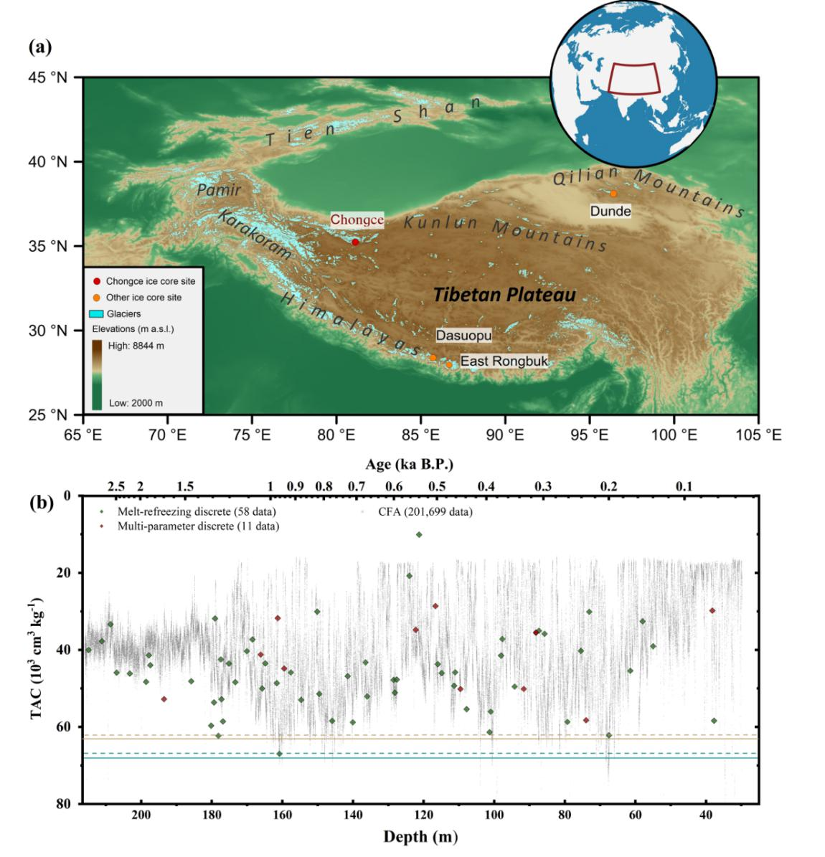

**Figure 1.** **(a)** The drilling site of the Chongce ice core (red dot) in the study, as well as the Dasuopu and East Rongbuk (red dot) ice cores used for ice core TAC analysis in previous studies of TP. Glacier data came from the Global Land Ice Measurements from Space (GLIMS, available at <http://www.glims.org>, last access: 4 October 2018). The topographic data used was extracted from ETOPO1 elevations global data, which is available at National Oceanic and Atmospheric Administration website <http://www.ngdc.noaa.gov/mgg/global/global.html> (last access: 4 October 2018). **(b)** Chongce ice core TAC sequences derived by three individual measurements, displayed on the depth scale covering the depth range from 29.76 m to 216.10 m. Grey dots correspond to CFA measurement data after calibration and validation. Green diamonds and yellow diamonds correspond to melt-refreezing and multi-parameter measurement results respectively, both passing through a regular calibration process. The chronology using here came from the outputs of the 2-parameter model. Blue line and blue dashed line represent the non-melt-state TAC at the core drilling site under modern climate condition and under LGM climate condition, respectively. Yellow line and yellow dashed line represent the non-melt-state TAC at the summit under modern climate condition and under LGM climate condition, respectively.

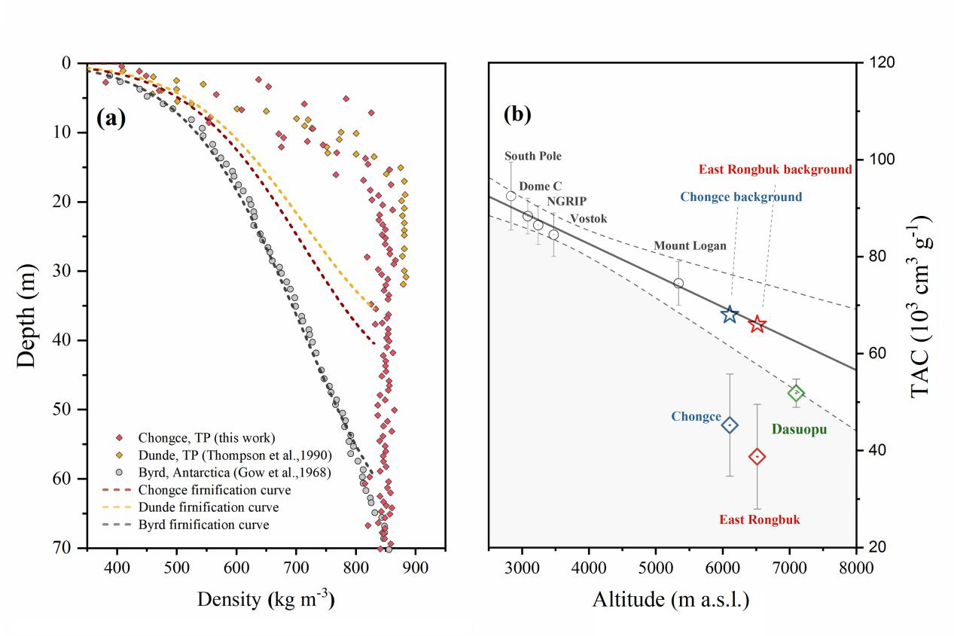

**Figure 2 (a)** Ice core density profile, revealing densification features between polar dry ices and melt disturbed ices. Polar ices include one from Byrd, Antarctica (*Gow*, 1968). Melt disturbed ice cores include one from Dunde, Tibetan plateau (*Thompson et al.*, 1990), another one from our Chongce records, which is converted from ice core weight.The dashed line are the theoretical densification curves for the three ice cores. **(b)** Relationship between ice core air content and elevation at the drilling site. The solid line corresponds to a linear relationship TAC (103 cm3 g-1) = 108.67 - 0.0065 × Elevation (m), and the dash lines corresponded to its 95% confidence intervals, fitting to five polar ice cores from polar sites (*Martinerie et al.*, 1992). The Area below the 95% confidence line was painted in light grey, corresponding to little or almost no elevation dominance to the ice core TAC fluctuation. The red star and diamond indicates the background value TAC level and ice core TAC level from East Rongbuk records (*Hou et al.*, 2007). Blue star and blue diamond indicate the background value TAC level and ice core TAC level from our Chongce ice core record. Green diamond represents the Dasuopu ice core TAC level (*Li et al.*, 2011).

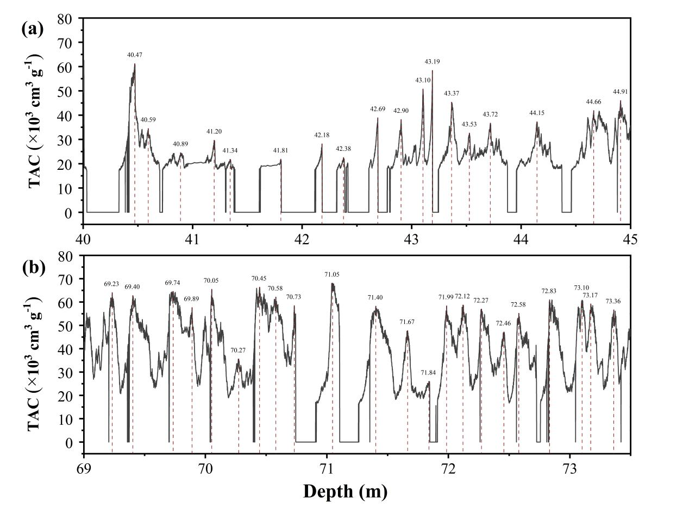

**Figure 3.** High-frequency of Chongce TAC signal in two typical depth ranges. (a) signal between the depth of 40 to 45 m. (b) signal between the depth of 69 m to 73.5 m. The red vertical lines that marked in the plot are peak values that automatically selected by the peak selection function of the origin software (the local point was set to be 65 and the peak threshold is 20% of the maximum value), which roughly corresponding to the alternation of annual layers.

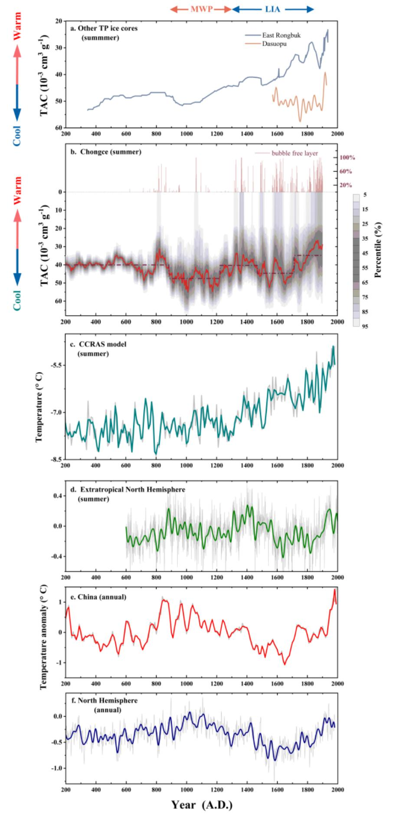

**Figure 4.** Comparison of temperature variations during the last two millennia between **(b)** our Chongce ice core TAC records with **(a)** other TP ice core records, including one from East Rongbuk ice core (the upper panel) which is a binomial smoothing trend of the combination of two ice core TAC sequences (Hou et al., 2007), as well as a series from Dasuopu ice core (the lower panel), which is a FFT smoothing trend with a low-pass cut-off frequency of 30 years (Li et al., 2011). **(c)** Climate model inferred summer temperature during the past 2000 years for the grid where the Chongce ice cap is located. The data came from the TraCE-21 ka project with ~3.75° latitude-longitude resolution (Collins et al., 2006). **(d)** Extratropical Northern Hemisphere summer temperature reconstruction (*Schneider et al.*, 2015), **(e)** China annual temperature reconstruction (*Yang et al.*, 2002) and **(f)** Northern Hemisphere annual temperature reconstruction (*Moberg et al.*, 2005). The grey lines in (d), (e) and (f) corresponds to the original data, and the colored lines displayed in the same plot correspond to its 30-year low-pass spline filter sequences. Plot (b) presents the 30-year median smoothing curve (red line) of the CFA test series, presented together are data number and the 5th to the 95th percentiles within each time step. Dashed lines in plot (b) are the distribution of regimes with statistically significant differences in mean values between adjacent periods (cut-off length =200 years, significant level = 1E-10, Huber’s weight parameters =1) (*Rodionov*, 2004). The Medival Warm Climate (MWP) and Little Ice Age (LIA) are marked in the top.